

AOS Agent Maintenance Mode MP 2012 Guide

Natascia Heil

Published: January 2013

Revision History

| **Release Date** | **Changes** |
| --- | --- |
| February 2013 | Updated MP to fit Atea Sverige AB - AOS |
| January 2013 | Original release of this guide |

Contents

AOS Agent Maintenance Mode 2012 Package for System Center Operations Manager 4

Changes in This Update 4

Getting Started 4

Before You Import the Monitoring Pack 5

Files in this package 5

Other Requirements 5

How to Import the AOS Agent Maintenance Mode 2012 management pack 5

Where to place the Other Files from the Monitoring Pack 5

Security Considerations 6

Low-Privilege Environments 6

Run As Profile 6

Understanding Management Pack Operations 6

Objects the AOS Agent Maintenance Mode 2012 management pack discovers 7

Classes 7

Viewing Information in the Operations Console 7

Key Monitoring Scenario 7

Rules 7

Write Actions 8

How to trigger agent maintenance mode 8

Trigger Maintenance Mode with the Splash Screen 9

Trigger Maintenance Mode with the VB Script 13

Known problems 14

AOS Agent Maintenance Mode 2012 Package for System Center Operations Manager

This package includes a management pack and some scripts that enable to set maintenance mode from the System Center Operations Manager agent. The provided scripts create an event log entry which is detected by the management pack and then initiates the maintenance mode on the associated management server.

Document Version

This guide was written based on the 1.0.0.2 version of the AOS Agent Maintenance Mode 2012 Package.

Getting the Latest Management Pack and Documentation

You can download the package at <http://www.systemcentercentral.com/PackCatalog/PackCatalogDetails/tabid/145/IndexId/94882/Default.aspx>

Changes in This Update

The January 2013 update (version 1.0.0.2) of AOS Agent Maintenance Mode 2012 Package for System Center Operations Manager included the following changes:

• Added “AOS Agent Maintenance Mode Class” to be able to also stop maintenance from the agent

* Updated Maintenance Mode Splash screen to confirm shutdown/reboot and check for maintenance mode before initializing shutdown/reboot. Also added stop maintenance mode button.
* Updated TriggerOM12MM.Instance.Event.vbs to also trigger stop maintenance mode.

Getting Started

This section provides information about implementing the AOS Agent Maintenance Mode 2012 Package for System Center Operations Manager.

Before You Import the Monitoring Pack

Before you implement the AOS Agent Maintenance Mode 2012 Package for System Center Operations Manager in the current version, know the following:

• If you have imported the old version of the AOS Agent Maintenance Mode 2012 package (1.0.01): the management pack can be upgraded. It also runs with the old splash screen and the old trigger VB script.

#### Files in this package

The entire package with binaries and management pack can be downloaded from this location:

<https://bitbucket.org/SamuelT_Atea/request-maintenance-mode>

The AOS Agent Maintenance Mode 2012 Package for System Center Operations Manager includes the following files:

* **AOS.Agent.MaintenanceMode.mp**: Sealed MP displayed as “AOS Agent Maintenance Mode 2012”.
* **RequestMaintenanceModeSetup.exe**: Setup program to install the request binaries on an agent system.

Files in the original package

You can download the original package from this location: <http://www.systemcentercentral.com/PackCatalog/PackCatalogDetails/tabid/145/IndexId/94882/Default.aspx>.

The Sample Agent Maintenance Mode 2012 Package for System Center Operations Manager includes the following files:

• AOS.Agent.MaintenanceMode.xml: Displayed as “AOS Agent Maintenance Mode 2012”.

 • OpsMgr2012.png: System Center Operations Manager 2012 logo.

• OpsMgrmm.lnk: Maintenance Mode splash screen shortcut, which calls powershell with remote signed execution policy and window style hidden. It launches c:\MM\OpsMgrMM.ps1.

• psMgrMM.ps1: PowerShell script, that creates the Maintenance Mode splash screen window to set maintenance mode on the agent computer.

• TriggerOM12MM.Instance.Event.vbs: VB Script which can be used to trigger the agent maintenance mode from a command line or called from another script.

Other Requirements

The AOS Agent Maintenance Mode 2012 Package for System Center Operations Manager is designed to run on System Center Operations Manager 2012 only. It also requires PowerShell 2.0 on the management servers and the agents.

How to Import the AOS Agent Maintenance Mode 2012 management pack

For instructions about importing a management pack, see (How to import an Operations Manager Management Pack) <http://technet.microsoft.com/en-us/library/hh212691.aspx>. It is recommended to seal the management pack before importing and then create an separate unsealed management pack for storing overrides.

Where to place the Other Files from the Monitoring Pack

To be able to launch the maintenance mode splash screen on an agent you need to copy the following files to c:\MM:

1. OpsMgr2012.png
2. OpsMgrMM.ps1
3. TriggerOM12MM.Instance.Event.vbs

The OpsMgrMM.lnk file should be copied to the All Users Startup folder in the start menu. Then it will be launched when a user logs on to the system.

The startup folder can be found here (two different locations depending on the version of Windows):

C:\Documents and Settings\All Users\Start Menu\Programs\Startup   
C:\ProgramData\Microsoft\Windows\Start Menu\Programs\Startup

Please use your software distribution program (SCCM or other) to distribute the files.

Security Considerations

This section provides information about using a low-privilege account with the AOS Agent Maintenance Mode 2012 Package for System Center Operations Manager.

Low-Privilege Environments

The AOS Agent Maintenance Mode 2012 management pack uses the agent action account to perform discovery and run rules. The agent action account can run as Local System or as a named account. When running as Local System, the agent action account has all of the rights needed to perform discovery and run rules.

Low-Privilege accounts are not tested, but the user would need permissions to read the event log and the registry to perform the discovery and run the rules.

Run As Profile

The AOS Agent Maintenance Mode 2012 management pack creates the “AOS Operations Manager Administrator Run As Profile” run as profile that is used within the rule “AOS - Event Log Entry triggers Maintenance Mode Rule” which triggers the maintenance mode on the management server.

Assign a System Center Operations Manager Administrator account to this profile and then the rule should run successful.

Understanding Management Pack Operations

This section provides information about the objects that are discovered, how health rollup works, key monitoring scenarios, and additional views that you can expect in the Operations Manager 2007 user interface as a result of importing this management pack.

Objects the AOS Agent Maintenance Mode 2012 management pack discovers

The AOS Agent Maintenance Mode 2012 management pack will, by default, discover the following object:

• AOS Agent Maintenance Mode Class

The discovery runs every 6 hours on the Windows Computer class and checks if the following registry key is available: \\HKLM\SOFTWARE\Microsoft\Microsoft Operations Manager\SCOM

Classes

The following table describes the available classes:

|  |  |
| --- | --- |
| **Available Classes** | **Description** |
| AOS Agent Maintenance Mode Class | All instances of Windows Computers that run SCOM. |

Viewing Information in the Operations Console

After you import the AOS Agent Maintenance Mode 2012 management pack, the following additions are made to Operations Manager 2012.

Monitoring Pane

The Maintenance Mode dashboard view is added to the Monitoring pane below the root folder.

Key Monitoring Scenario

The AOS Agent Maintenance Mode 2012 management pack provides monitoring to detect that a maintenance mode start or stop command has been triggered on an agent.

Rules

The following rules are all running on the discovered “AOS Agent Maintenance Mode Class”.

|  |  |
| --- | --- |
| AOS - Event Log Entry Triggers Alert Rule | Checks the Operations Manager event log for an event with the ID 997 and the source “Health Service Script”. Generates an alert with the name “AOS Maintenance Mode 2012 - Maintenance Mode was Triggered On The Agent”. |
| AOS - Event Log Entry triggers Maintenance Mode Rule | Checks the Operations Manager event log for an event with the ID 997 and the source “Health Service Script”. Triggers the “AOS - Event Log Entry Triggers Maintenance Mode Write Action” on the “Management Server” class. |

Write Actions

|  |  |
| --- | --- |
| AOS Maintenance Mode 2012 - Maintenance Mode was Triggered On The Agent | Runs in the context of the “AOS Operations Manager Administrator Run As Profile”.  Sets or unsets the maintenance mode related to what is defined in the event description.  The keyword is ‘Start’ or ‘Stop’ – if nothing is provided then ‘Start’ is used.  The description has the following setup:  Keyword;Duration;Reason;Class;Instance;Comment Example:  Stop;10;ApplicationInstallation;Microsoft.Windows.Client.Win7.DiskPartition;Disk #0;domain\username;12/12/2012 05:40:00 PM  Related to what is given, it sets the maintenance mode for the whole computer (no class and instance defined), all instances of a class (no instance defined) or only the instance.  It will always unset the maintenance mode for the "AOS Agent Maintenance Mode Class” to enable monitoring for the stop maintenance mode events.  Example to start maintenance if no class and instance is defined:  Start;10;ApplicationInstallation;;;domain\username;12/12/2012 05:40:00 PM |

How to trigger agent maintenance mode

Agent maintenance mode start or stop can be triggered through two options:

1. Maintenance Mode Splash Screen (OpsMgrMM.lnk)
2. The VB script TriggerOM12MM.Instance.Event.vbs

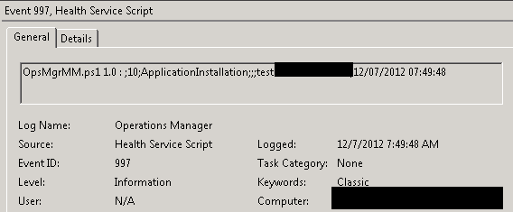

Both options will write an entry into the Operations Manager event log with the ID 997 and the source “Health Service Script”.

Trigger Maintenance Mode with the Splash Screen

The Maintenance Mode Splash screen will pop up when the OpsMgrMM.lnk has been called.  
*Attention! PowerShell 2.0 is needed on the machine, otherwise the window will not pop up!*

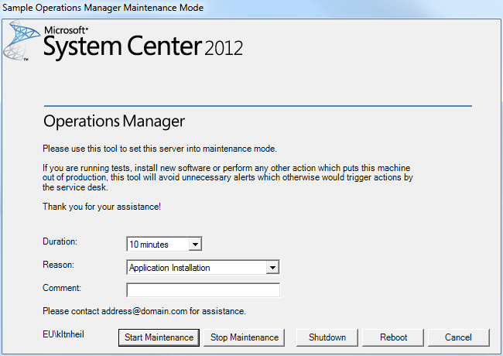

It will always set the whole Windows computer into maintenance mode with all classes below that (only the “AOS Agent Maintenance Mode Class” will stay without maintenance mode). If you need to set a class or instance of a class into maintenance mode, then you have to use the VB script.

You have three options to start maintenance mode and one option to stop maintenance mode.

All options will write an event log entry with the description: Keyword;Duration; ApplicationInstallation;;;Comment. The only difference is the keyword. It will be set to “Start” for all start maintenance buttons and “Stop” for the stop maintenance button. The Comment is always a combination of Comment, Username and time eventlog entry created (“Comment:Username;date/time”).

*Example: OpsMgrMM.ps1 1.0 :* *Start;10;ApplicationInstallation;;;test:domain\username;12/07/2012 03:40:41*

Start Maintenance Mode and Stop Maintenance Mode will only write the event log entries and then wait for the maintenance mode to be set or unset.

Shutdown and Reboot will first write the event log entry, then wait for the maintenance mode to be set and then initialize the shutdown or reboot command.

The following windows will appear when one of the options is clicked:

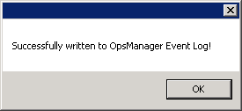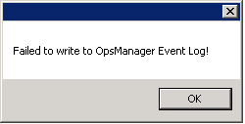

This window only appears if it cannot write to the Operations Manager event log.

It waits up to 5 minutes if the maintenance mode was set or unset successfully.

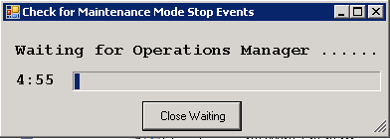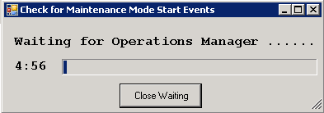

*Attention! Please do not close this window otherwise it will not wait until the maintenance mode is set and starts the next step immediately (i.e. Shutdown/Reboot).*

Then it will show one of these windows:

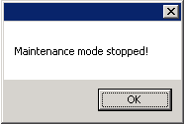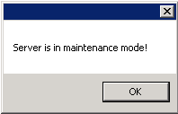

Otherwise it will show one of these windows:

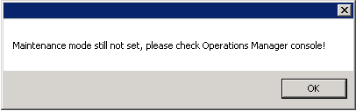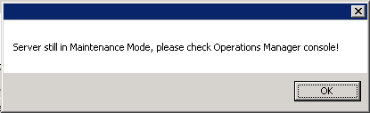

If Shutdown or Reboot was selected then it first asks to confirm the shutdown or reboot command to avoid wrong clicks.

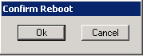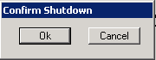

Then it writes the event log entry and when the maintenance mode was set successful it starts the shutdown or reboot.

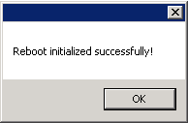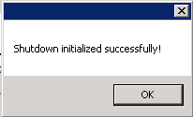

Trigger Maintenance Mode with the VB Script

This option has two main benefits. It can trigger maintenance mode also for a whole class or single instances of a class and it can be called from another script or within a scheduled task. So recurring tasks which shutdown services could call the maintenance mode script first before the service gets restarted.

Another benefit of this solution is that no PowerShell is needed on the agent to trigger agent maintenance mode.

The script can be called like this:

*cscript.exe TriggerOM07MM.Instance.Event.vbs <maintenance mode duration in mins> <comment for maintenance> <class> <instance> [Start|Stop]*

Examples:

*Start Maintenance mode for single instance:*cscript.exe TriggerOM12MM.Instance.Event.vbs 15 "Monthly server reboot." "Microsoft.Windows.Server.2003.LogicalDisk" "C:" "Start"

*Start Maintenance mode for whole class:*cscript.exe TriggerOM12MM.Instance.Event.vbs 15 "Monthly server reboot." "Microsoft.Windows.Server.2003.LogicalDisk" "" "Start"

*Start Maintenance mode for whole system:*cscript.exe TriggerOM12MM.Instance.Event.vbs 15 "Monthly server reboot." “" "" "Start"

*Stop Maintenance mode:*cscript.exe TriggerOM12MM.Instance.Event.vbs 15 "Monthly server reboot." "" "” "Stop"  
Attention! You also have to provide a duration and a comment also if it will not be used!

The script writes an event log entry to the Operations Manager log:

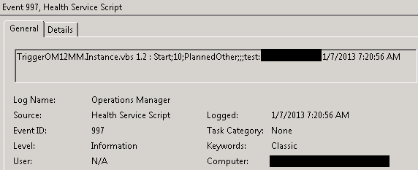

Known problems

If an agent is multi homed, then this solution will only work in the environment where the AOS Agent Maintenance Mode management pack is implemented.